Determination of Lead (Pb) in Water using FAAS
Calibration Standards
Pb (mg/L) | Absorbance (A)
0.0 | 0.005
0.5 | 0.105
1.0 | 0.205
2.0 | 0.405
Sample Absorbance: A = 0.255
Step 1: Calibration Curve Equation
A = m * C + b
- Slope (m): (0.205 - 0.105) / (1.0 - 0.5) = 0.200
- Intercept (b): 0.005
- Calibration equation: A = 0.200 * C + 0.005
Step 2: Solve for Sample Concentration
0.255 = 0.200 * C + 0.005
0.250 = 0.200 * C
C = 0.250 / 0.200 = 1.25 mg/L
Answer: Pb concentration in the water sample = 1.25 mg/L

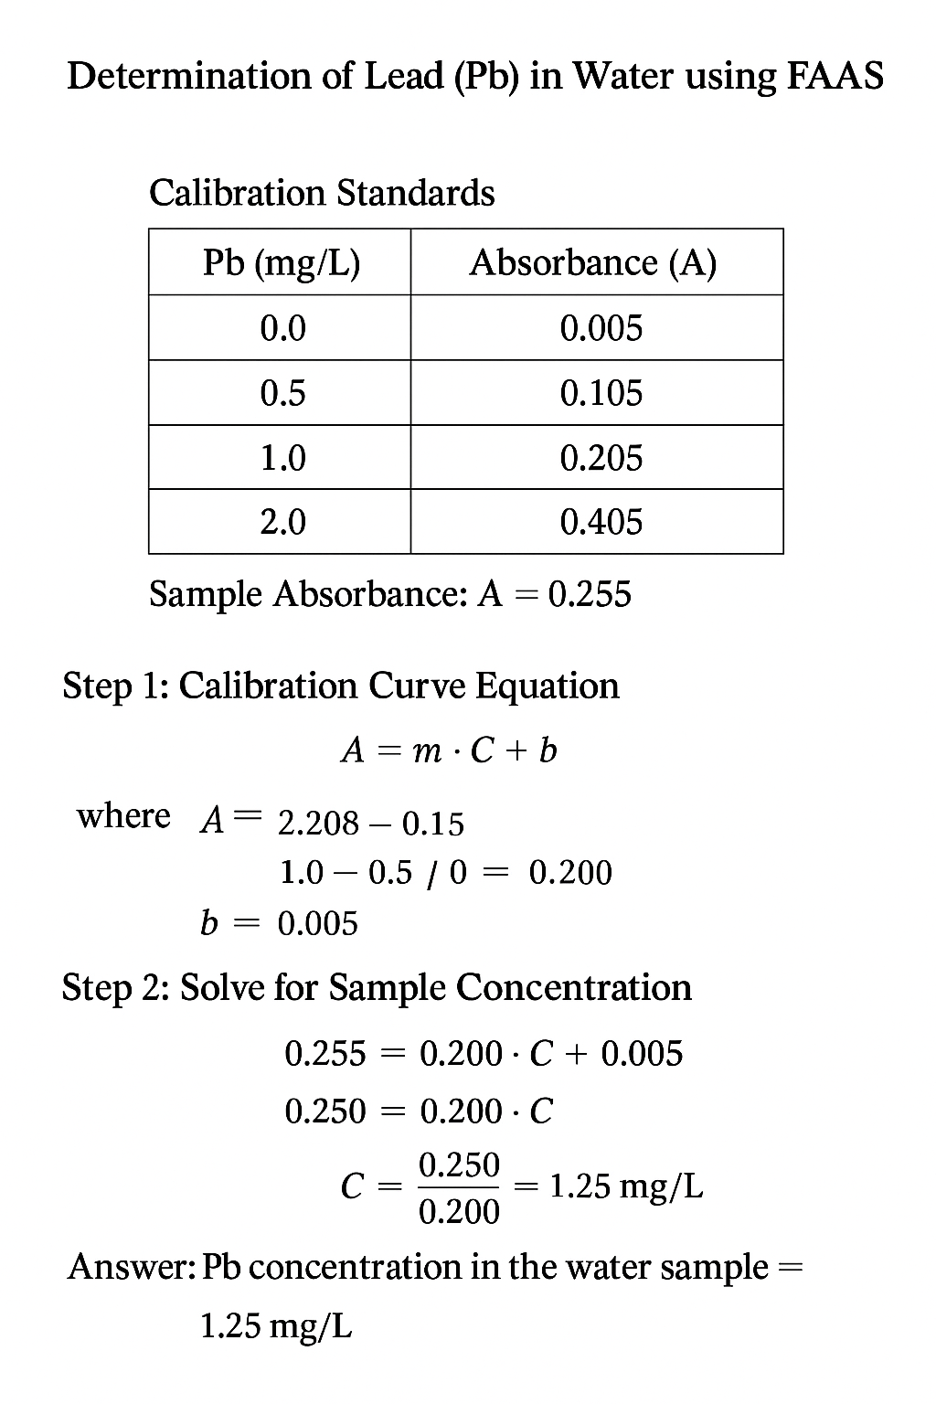

Q2/

A water sample is analyzed for lead (Pb) using FAAS.
A 10.0 mL aliquot of the sample is diluted to 100.0 mL in a volumetric flask before measurement.
The following calibration data were obtained:
Pb (mg/L) | Absorbance (A)
0.00 | 0.000
0.50 | 0.110
1.00 | 0.210
2.00 | 0.410
3.00 | 0.610
The absorbance of the diluted sample is A = 0.315.
…………………………………………………………………………………………………………………………………………………………………
